Project Design Phase
Use-Case Diagram
Date | 21 October 2026
Team ID | SWUID2026403023
Team Members | Individual project (single member)
Project Name | StaffSync
Maximum Marks
Document Version | v1.2 (revised 27 October 2026; originally issued 21 October 2026 as v1.0)
Use-Case Diagram:
Manager and HR are also employees, so they inherit the Employee actions, except viewing assigned training and updating its progress, which is Employee-only in the permission matrix.
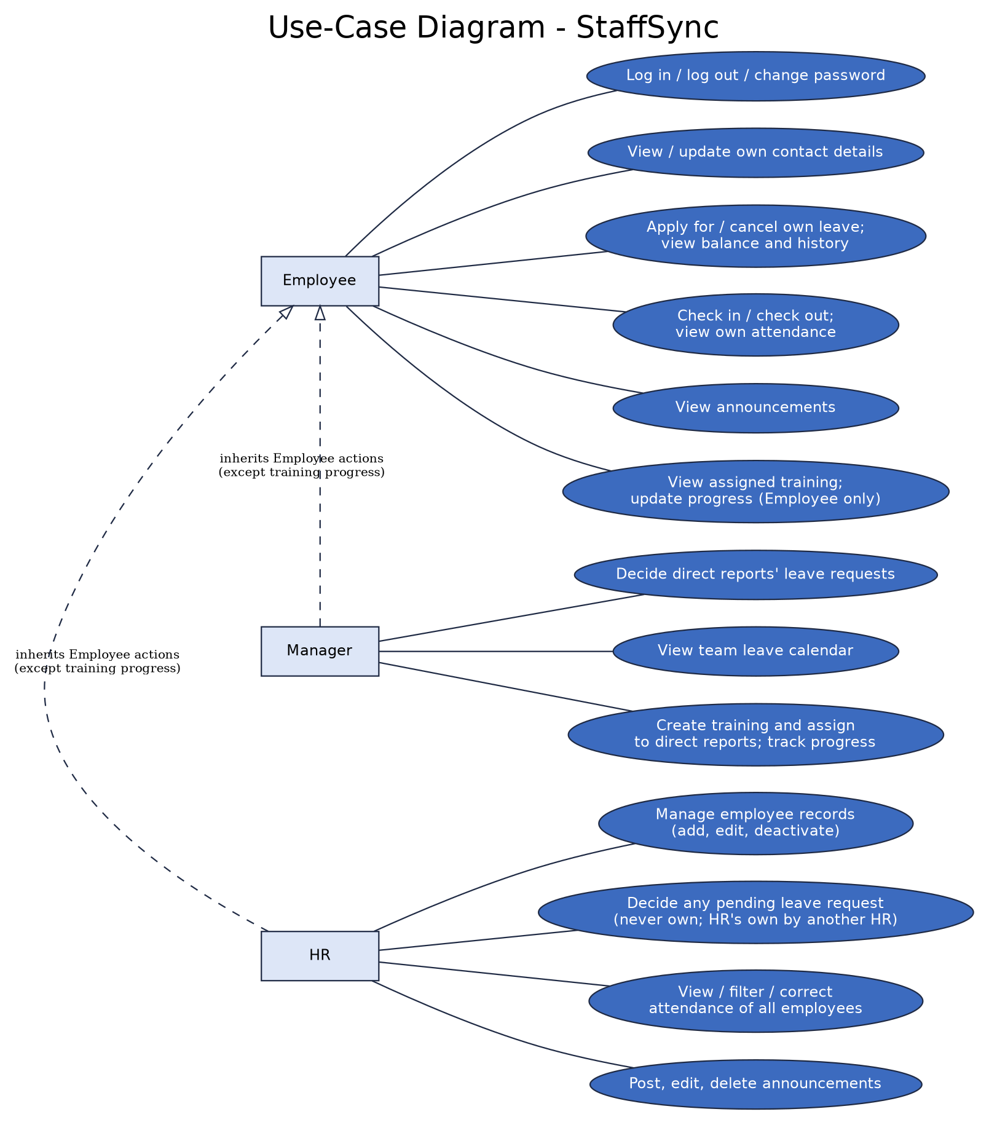
Figure 1: StaffSync use cases by role
Actions by Role
Role | Actions
Employee | Log in; update own contact details; apply for or cancel own leave; check in / out and view own attendance; view announcements; view assigned training and update progress
Manager | All Employee actions except training progress; decide direct reports' leave requests; view the team leave calendar; create training, assign it to direct reports and track their progress
HR | All Employee actions except training progress; add, edit and deactivate employees; decide any pending leave request except own (an HR user's own request is decided by another HR user); view, filter and correct attendance; post, edit and delete announcements

Revision History
Version | Date | Summary of changes
v1.0 | 21 October 2026 | Initial issue.
v1.1 | 23 October 2026 | Redrawn diagram: team leave calendar, training progress tracking and the HR own-leave rule added; unused images removed from the file.
v1.2 | 27 October 2026 | Aligned the project overview and role/module descriptions with the current StaffSync stack and demo deployment; retained detailed design notes and planned-vs-actual distinctions.

